

**POORNIMA AYURVEDIC MEDICAL COLLEGE, HOSPITAL & RESEARCH CENTRE**

OPD SHEET

Patient Name: UHID No: OP No:

Age: yrs Ref:

Gender: M/F Contact No:

Address: Doctor:

Department:

* Chief Complaints:
* Associated Complaints:
* Past History:
* Personal History:
* Allergy History:
* Family History:
* Obs & Gyn Histroy: (Applicable for female patients only)
* Examination:
* General Examination

Ht: Wt: BMI: Pulse: RR: BP:

* Systemic Examination
* Respiratory System-
* CVS:
* CNS:
* Local Examination
* **Pain Assessment(applicable only for pain predominant cases):**

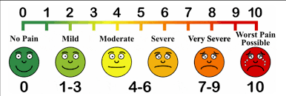

* **Investigations(if any):**
* **Provisional Diagnosis/Final Diagnosis**
* **Screening for Nutritional Needs:** 
  + **Nutritional Status: Normal/mild malnutrition/moderate malnutrition /severe malnutrition.**
* **Treatment Plan/Care of Plan:**
* **Preventive aspects PathyaApathya/NidanaParivarjana (if any):**
* **Rehabilitation-Physiotherapy/Rasayana/Apunarbhav**
* **Desired outcome:**

**Doctor Name, Signature with date & Time**